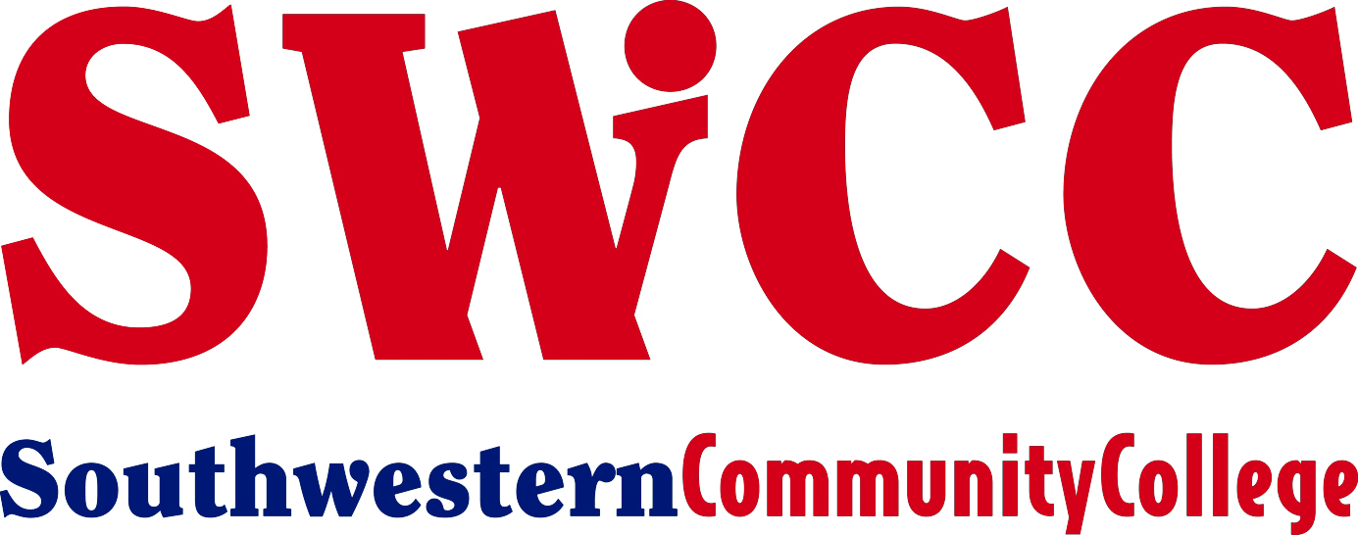

1501 W Townline Street

Creston, IA 50801

641.782.7081

www.swcciowa.edu

For Immediate Release

November 1, 2023

Contact: Paige Russo, SWCC head dance coach
641.782.1384 or russo@swcciowa.edu

PHOTO: Messler_Joslyn_SWCCdance.jpg

PICTURED: Sitting (L to R) – Steve Messler, Joslyn’s father; Joslyn Messler; and Megan Messler, Joslyn’s mother.
Standing – Paige Russo, Southwestern head dance coach.

Spartans sign first dancer of 2024 recruiting class

Creston, IA—Southwestern Community College’s dance program has begun recruitment for the college’s 2024-25 dance team and Joslyn Messler of Boone is the first member of the 2024 recruiting class.
Messler will be a May 2024 graduate of Boone High School in Boone. As a senior, she is a three-year varsity letter winner in track and two-year varsity letter winner in wrestling cheer. She has been a member of the high school dance team for two years and has 15 years of studio experience in jazz.
“Joslyn is our first official signee for the 2024-25 academic year and we are extremely excited to have her as a part of the team,” said Paige Russo, Spartan head dance coach. “Joslyn will be a huge asset to the team and it’s exciting to kick off the start of our recruitment season!”
She is the daughter of Steve and Megan Messler of Boone.
###

